Git & GitHub Challenge Task -02
1)Resolve Merge Conflicts
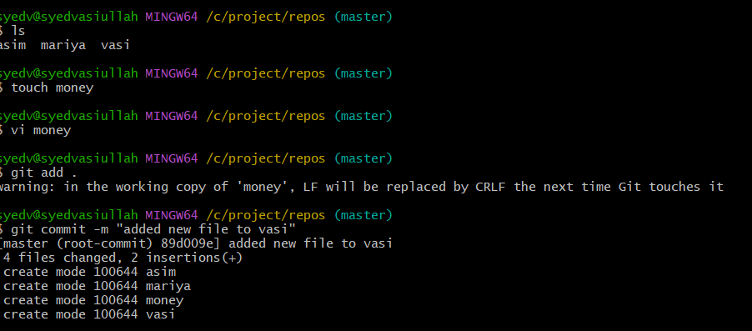

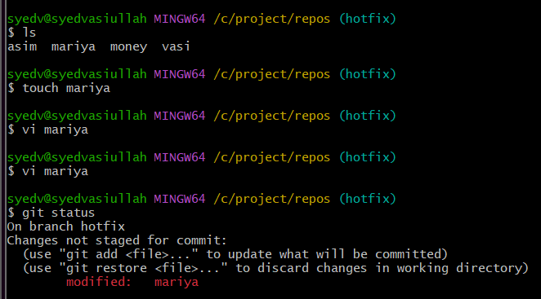
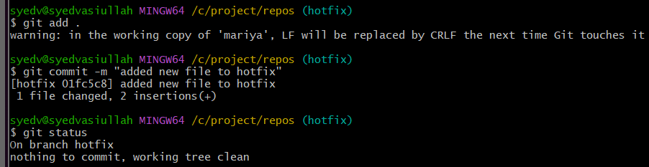
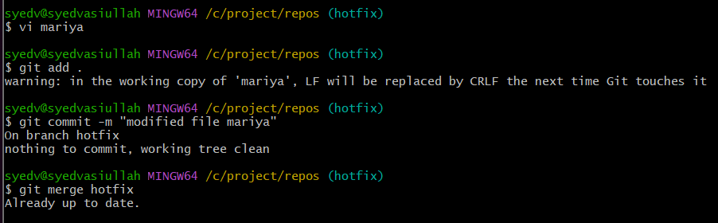
2) Recover Deleted Branch

- git reflog
- Reflog shows all recent HEAD positions.
- Example output
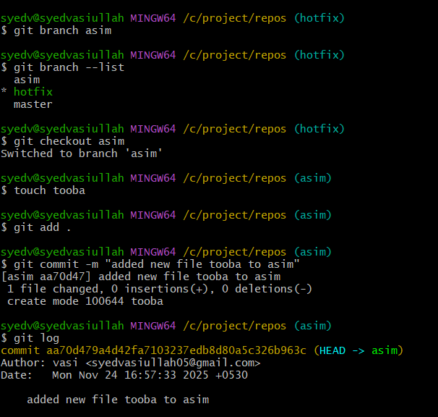
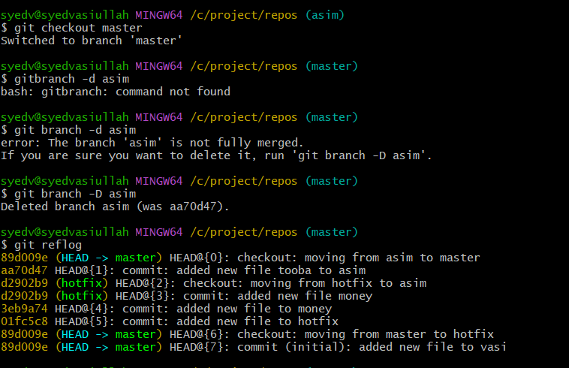
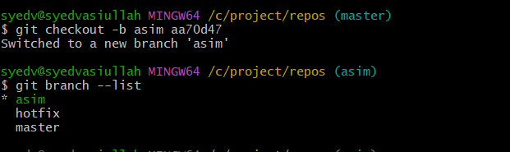
3) Undo Wrong Push
Touch filename
git add .
git commit -m "Remove wrong file"
git push
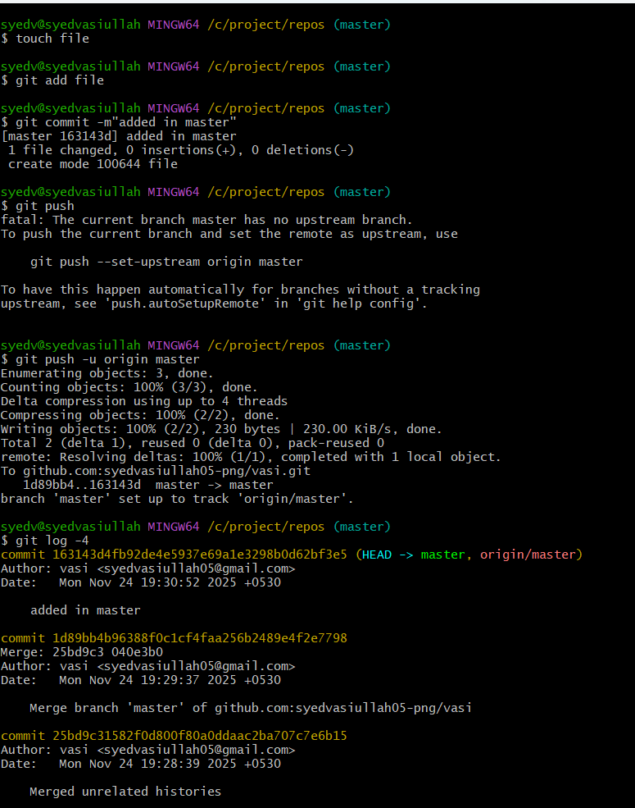
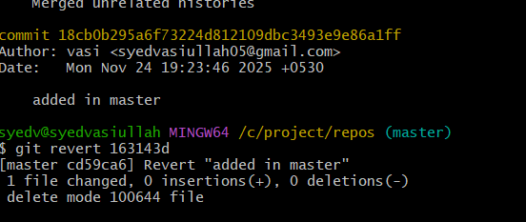
4) Amend a Commit
git commit --amend allows you to:
- Fix the last commit message
- Add forgot files to the last commit
- Modify the content of the last commit
- Avoid creating a new commit
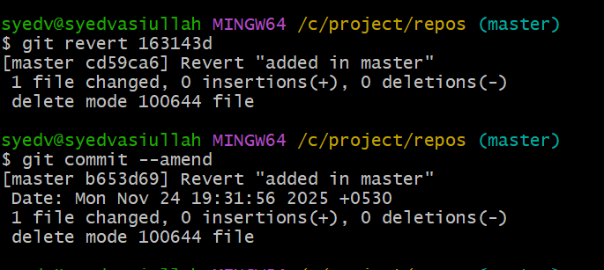

5) Cherry pick a commit
- git cherry-pick lets you take one specific commit from one branch
and apply it on another branch.

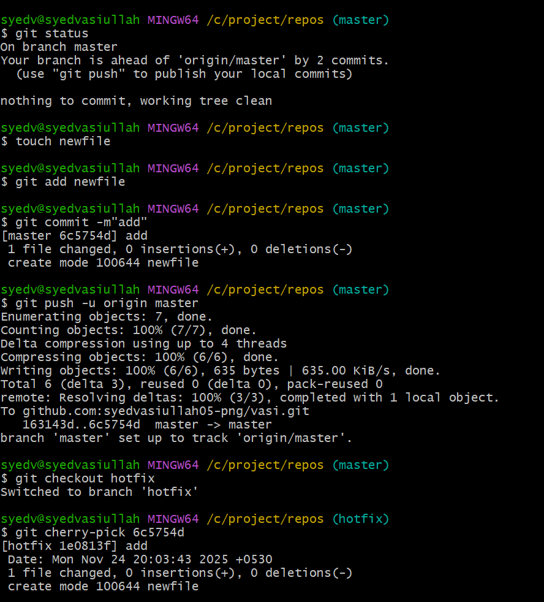

6) Interactive Rebase
- Rebase = “move commits to a new base.”
- Interactive rebase allows you to edit, reorder, squash, or delete commits before merging.
- Useful for cleaning up commit history before pushing to the main branch.

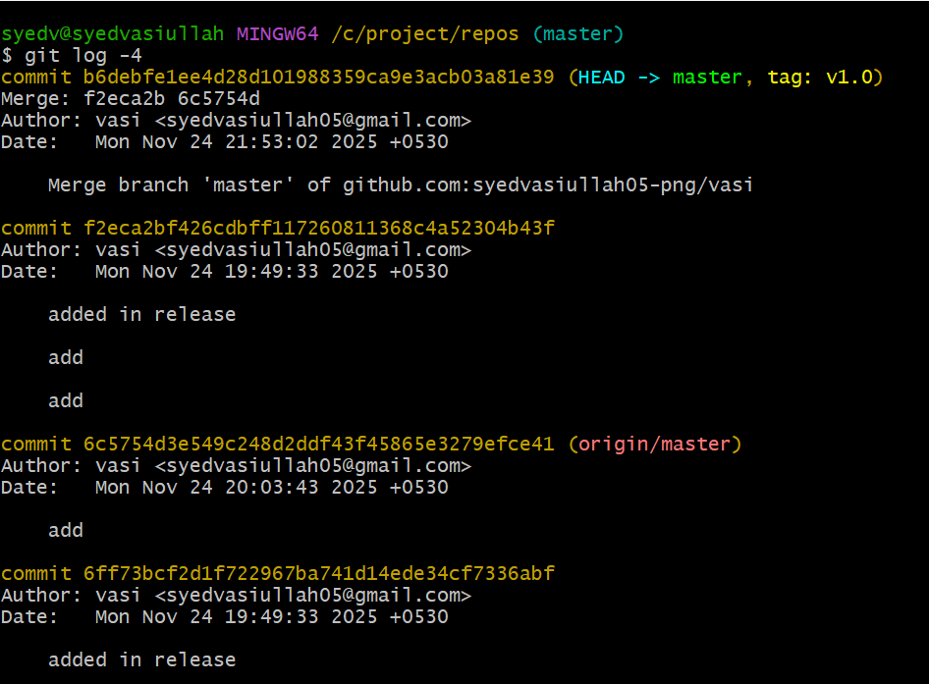

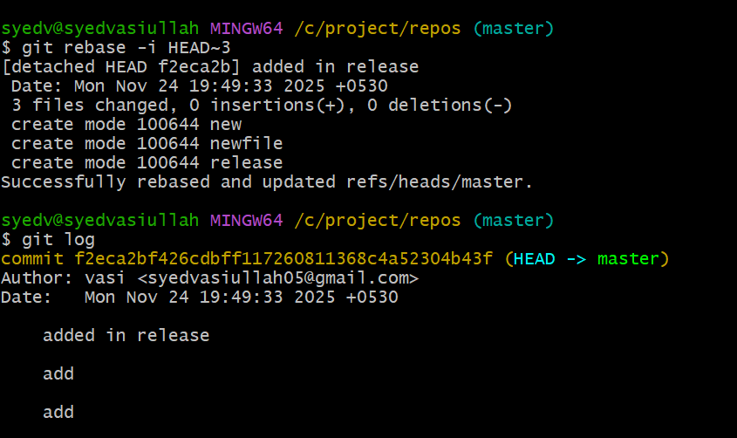

7) Tagging & Release
- Go to GitHub → Releases → New Release
- git tag v1.0.0
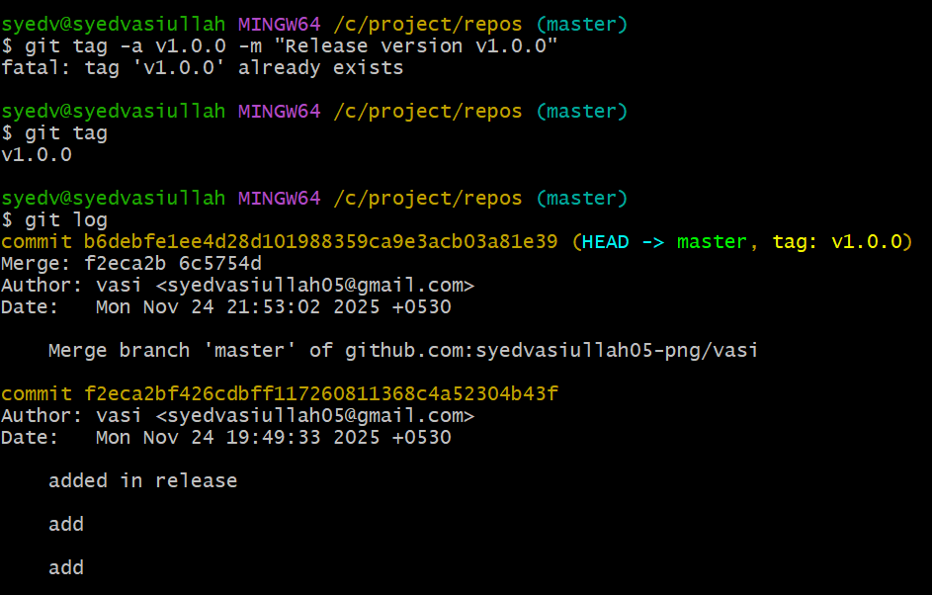
- git tag push v1.0.0

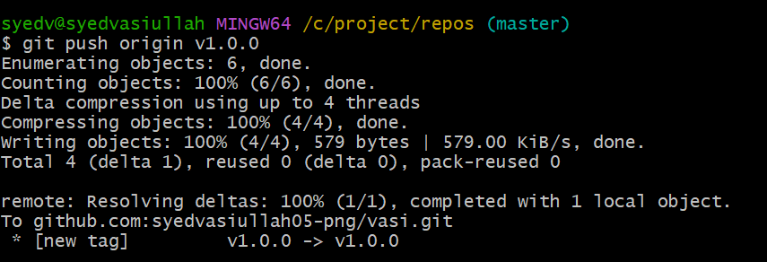

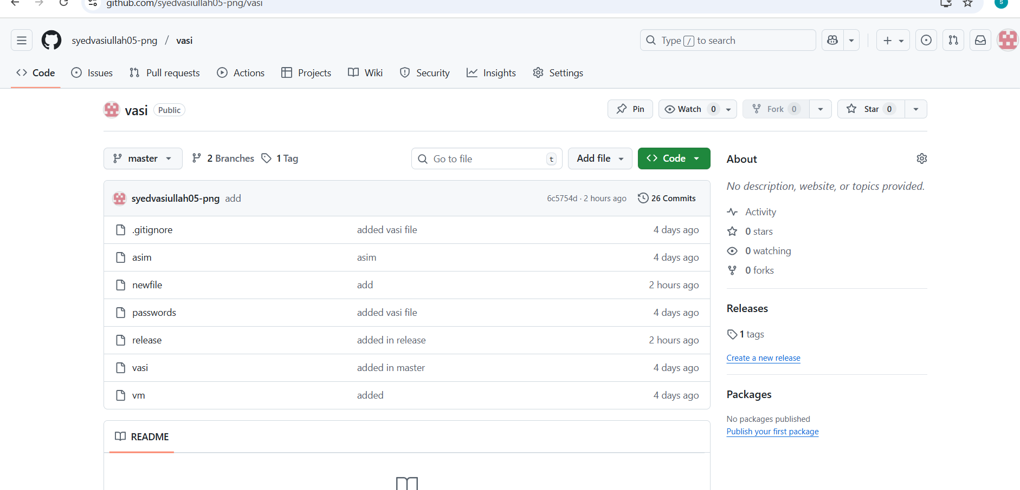
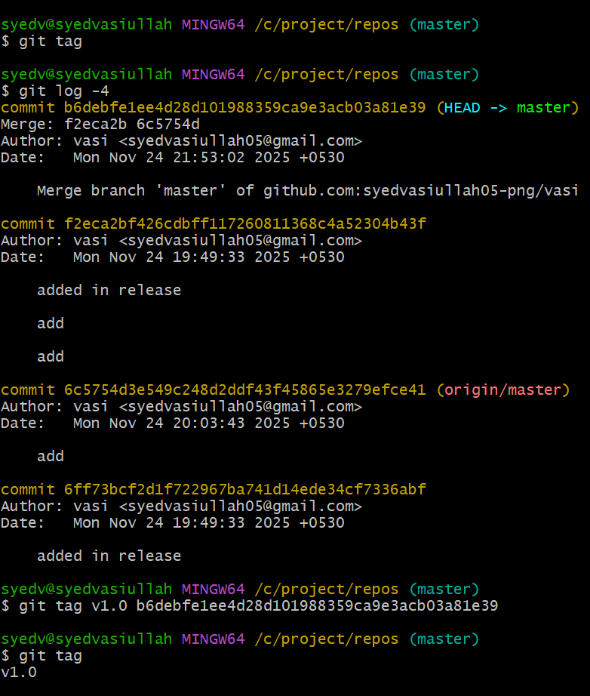
8) Clone with Sparse Checkout
- Normally, git clone fetches the entire repository.
- Sparse Checkout allows you to clone only specific folders or files from a repo.
- Useful for large repositories where you don’t need everything.
git clone --no-checkout git@github.com:syedvasiullah05png/vasi.git
cd vasi
git sparse-checkout init --cone
git sparse-checkout set src config
git checkout master
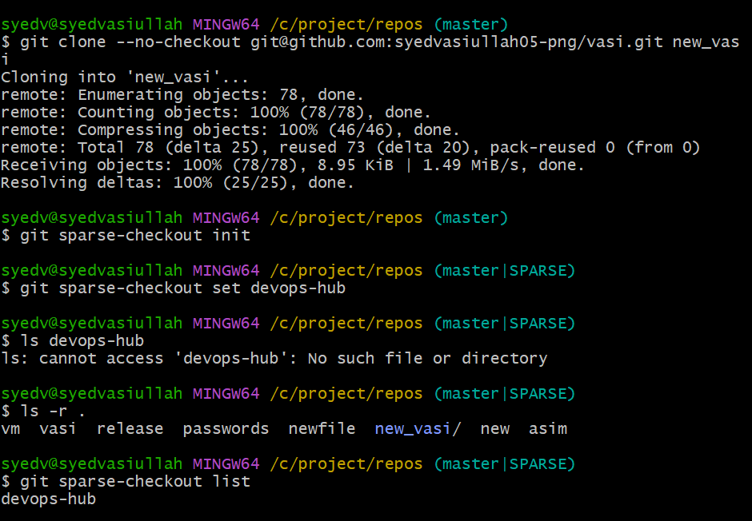

9) Reset vs Revert Challenge
- RESET = Time Travel BACKWARD (Change History)
- RESET
- You haven’t pushed your changes
- You want to rewrite local history
- You are cleaning messy commits before a clean push
- Working alone or on a feature branch
- REVERT = Create an Opposite Commit
- REVERT
- You already pushed the commits
- You are working in a team
- You want to undo without breaking Git history
- You want a clean rollback commit

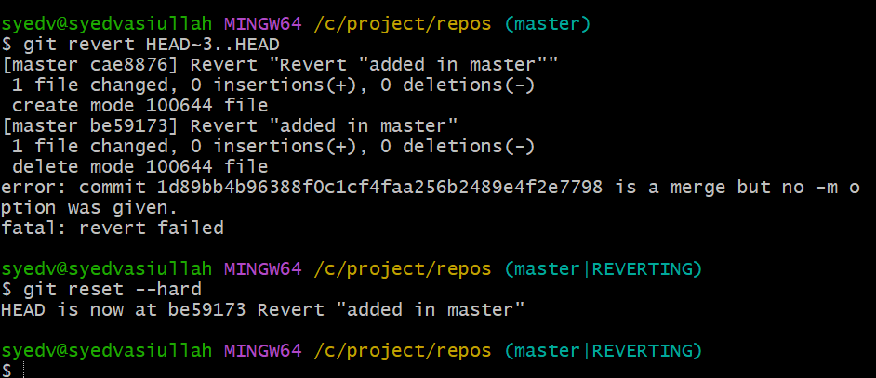

10) Detached HEAD Challenge
- Checkout an old commit (detached HEAD).
- Make two commits while detached.
- Save the commits by creating a new branch.
- Switch back to master and verify your new branch has commits.
- Optionally, discard a commit and recover it using reflog.

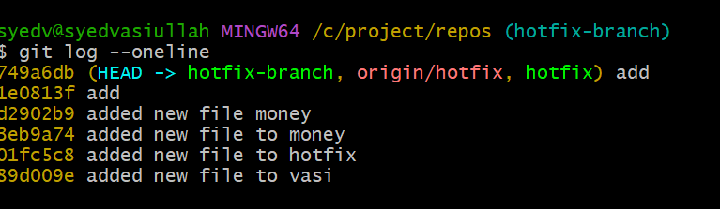
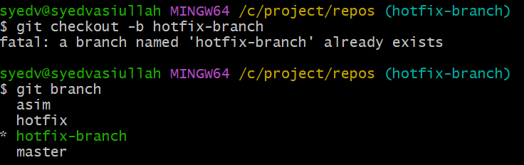

12) Squash Merge vs Rebase Merge
- Squash Merge
- Combines all commits from a feature branch into one single commit before merging into the target branch.
- Keeps the target branch clean, without all the small intermediate commits.
- Original commit history on the feature branch is lost (squashed into one).
- Use Case: Small features, hotfixes, or when you want a clean main branch.
- Rebase Merge
- Takes the commits from the feature branch and replays them on top of the target branch.
- Keeps all individual commits intact but creates a linear history without merge commits.
- Rewrites history on the feature branch (do not rebase public branches).
- Use Case: Long-running features, detailed commit history, or linearizing history before merging.
